**Week3 Assignment:**

**FoodieDash** is an app that helps you order food from local restaurants and get it delivered to your door. You can choose from a variety of cuisines, place your order, and track it to know when it will arrive. The app also lets you read reviews and enjoy special promotions to make your food ordering experience even better.

The underlying entities are as follows

**UserMaster:**

The UserMaster table stores information about users, including their contact details, delivery address, and payment information. Each column represents a specific aspect of a user's profile.

* **UserID**: Unique identifier for each user in the system.
* **Name**: The user's full name.
* **MobileNo**: mobile number of the employee.
* **EmailID**: Email of the employee
* **DeliveryAddress**: The address where goods or services are delivered.
* **PaymentDetails**: Information related to payment methods or transactions.

**Restaurant:**

The Restaurant table stores information about restaurants, including their name, cuisine type, location, and contact information.

* **RestaurantID**: Unique identifier for each restaurant in the system.
* **Name**: The name of the restaurant.
* **CuisineType**: The type of cuisine served at the restaurant.
* **Location**: The physical location or address of the restaurant.
* **ContactInfo**: Contact information for the restaurant, such as phone number or email.

**Orders:**

The Orders table tracks orders placed by users at restaurants, including details about the items ordered, delivery status, and delivery details.

* **OrderID**: Unique identifier for each order.
* **UserID**: Identifier for the user who placed the order.
* **PromotionID**: Identifier for the each promotion.
* **RestaurantID**: Identifier for the restaurant from which the order was placed.
* **ItemsOrdered**: Details about the items ordered, which could include names or IDs.
* **OrderStatus**: The current status of the order (e.g., pending, in progress, delivered).
* **DeliveryDetail**: Information about the delivery, such as the delivery address or expected delivery time.

**Reviews:**

The Reviews table stores reviews written by users for restaurants, including ratings and comments about their experiences.

* **ReviewID**: Unique identifier for each review.
* **UserID**: Identifier for the user who wrote the review.
* **RestaurantID**: Identifier for the restaurant being reviewed.
* **Rating**: The numerical rating given by the user (e.g., on a scale of 1 to 5).
* **Comments**: Any additional comments or feedback provided by the user.
* **Review**: A text field containing the full review.

**Promotions:**

The Promotion table stores information about promotions offered by restaurants, including details about the promotion, its validity period, and any associated terms and conditions.

* **PromotionID**: Unique identifier for each promotion.
* **RestaurantID**: Identifier for the restaurant offering the promotion.
* **PromotionDetails**: Description of the promotion.
* **ValidityPeriod**: The period during which the promotion is valid.
* **Terms**: Any specific terms and conditions associated with the promotion.
* **Promotion**: A text field containing additional information about the promotion.

|  |  |
| --- | --- |
| **UserMaster** |  |
| UserID (PK) | INT |
| Name | VARCHAR (200) |
| MobileNo | VARCHAR (20) |
| EmailID | VARCHAR (50) |
| DeliveryAddress | VARCHAR (500) |
| PaymentDetails | VARCHAR (200) |

|  |  |
| --- | --- |
| **Restaurant** |  |
| RestaurantID (PK) | INT |
| Name | VARCHAR (200) |
| CuisineType | VARCHAR (50) |
| Location | VARCHAR (500) |
| ContactInfo | VARCHAR (200) |

|  |  |
| --- | --- |
| **Order** |  |
| OrderID (PK) | INT |
| PromotionID (FK) | INT |
| UserID(FK) | INT |
| RestaurantID(FK) | INT |
| ItemsOrdered | VARCHAR (500) |
| OrderStatus | TINYINT |
| DeliveryDetails | VARCHAR (500) |

|  |  |
| --- | --- |
| **Reviews** |  |
| ReviewID (PK) | INT |
| UserID(FK) | INT |
| RestaurantID(FK) | INT |
| Rating | FLOAT |
| Comments | VARCHAR (500) |

|  |  |
| --- | --- |
| **Promotion** |  |
| PromotionID (PK) | INT |
| RestaurantID(FK) | INT |
| PromotionDetails | VARCHAR (500) |
| ValidityFrom | DATE |
| ValidityTo | DATE |
| Terms | TEXT |

4.

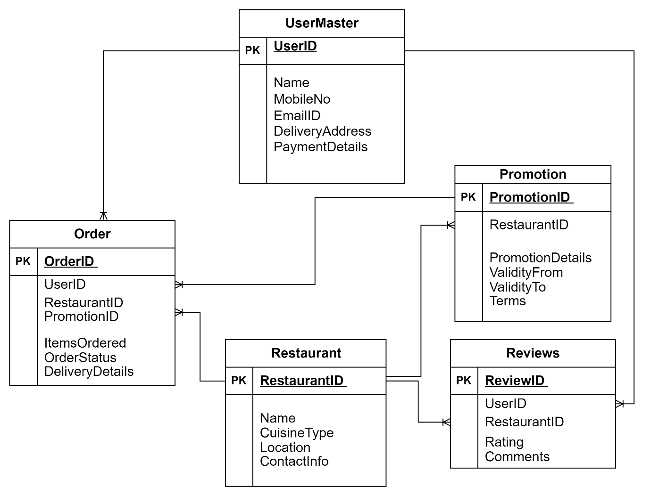

1. **UserMaster**:
   * Connected to Orders in a One-to-Many relationship (One user can place many orders).
   * Connected to Reviews in a One-to-Many relationship (One user can write many reviews).
2. **Restaurant**:
   * Connected to Orders in a One-to-Many relationship (One restaurant can receive many orders).
   * Connected to Reviews in a One-to-Many relationship (One restaurant can receive many reviews).
   * Connected to Promotions in a One-to-Many relationship (One restaurant can offer many promotions).
3. **Orders**:
   * Connected to UserMaster in a Many-to-One relationship (Many orders are placed by one user).
   * Connected to Restaurant in a Many-to-One relationship (Many orders are placed at one restaurant).
4. **Reviews**:
   * Connected to UserMaster in a Many-to-One relationship (Many reviews are written by one user).
   * Connected to Restaurant in a Many-to-One relationship (Many reviews are written for one restaurant).
5. **Promotions**:
   * Connected to UserMaster in a Many-to-One relationship (Many promotions can be availed by one user).
   * Connected to Restaurant in a Many-to-One relationship (Many promotions are offered by one restaurant).